French 1A – Unit 1: Small Talk
Devoirs #4 – Telling Time
Nom ___________________
Heure __________________
Draw the time on the clock based on the time given:
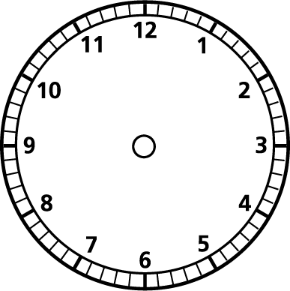 | : |  | :
1. Il est quatre heures. | 2. Il est onze heures quinze. | 3. Il est huit heures vingt. | 4. Il est une heure quarante-quatre.
: |  | :
5. Il est deux heures cinquante-deux. | 6. Il est neuf heures vingt. | 7. Il est dix heures quatorze. | 8. Il est sept heures trente-trois.

Write a sentence in French that indicates the time shown on each clock:
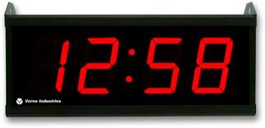 | 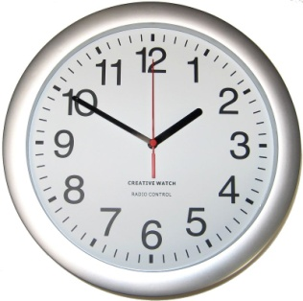 | 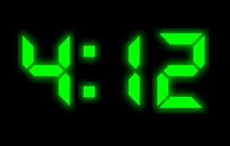 | 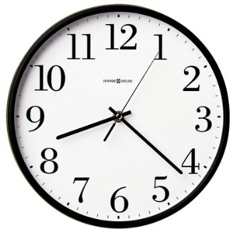
9. _____________________  _____________________ | 10. ____________________  ____________________ | 11. ____________________  ____________________ | 12. ____________________  ____________________
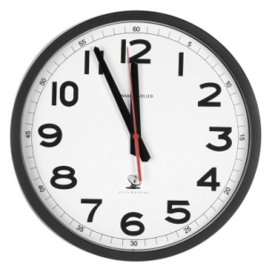 | 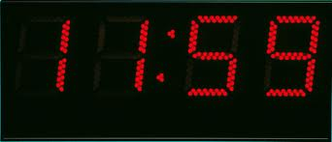 | 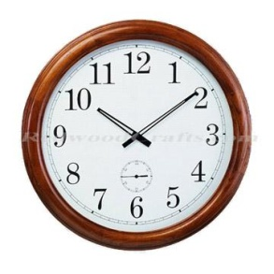 | 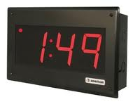
13. ____________________  ____________________ | 14. ____________________  ____________________ | 15. ____________________  ____________________ | 16. ____________________  ____________________

