French 1A: Unit 1 Le Temps
Devoirs #5
Nom ______________________
Heure _____________________
Below you will find a map of France. Based on what we learned about the geography of France and the pictures on the map below, write a weather the weather in each city.
LE NORD
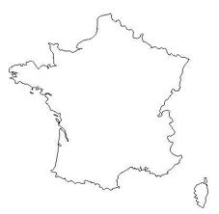
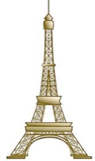
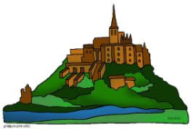
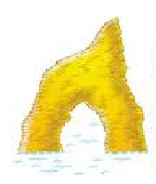
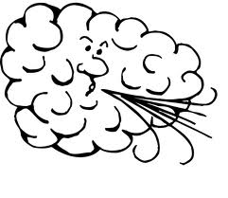
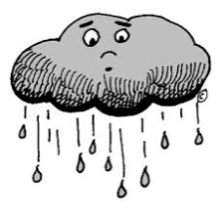
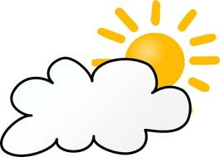

Mt. Saint Michel
(La Bretagne)
Paris
L’OUEST
L’EST

Chamonix

Biarritz
Nice

LE SUD

- À Paris _______________________________________________________
- À Mt. Saint Michel ____________________________________________
- À Biarritz ____________________________________________________
- À Nice _____________________________________________________
- À Chamonix _________________________________________________

For each of the following statements write Vrai(true) or Faux(false) on the line provided. **You may need to look up the seasons in your weather notes or the city on the back side of this sheet in order to see where each city is located.
- À Paris en été il fait froid et il neige. | _______________
- À Nice il fait souvent (often) beau. | _______________
- Le temps à Paris est comme (like) le Michigan. | _______________
- À Mont Saint Michel en hiver il fait du soleil et il fait chaud. | _______________
- À Chamonix, dans les montagnes, il neige beaucoup (a lot). | _______________
- En Bretagne, au nord-ouest (NW) de la France, il pleut beaucoup. | _______________

Figure out what weather would be happening if the temperatures were those in Celsius below and write a weather statement in French. (use the chart to help you know the conversion)
**On the line don’t write the temperature in Fahrenheit but what the weather would probably be…
- 0˚C ________________________

- 37.8˚C ______________________

- 10˚C _______________________

- 23˚C _______________________

Temp. In F˚ | Temp. In C˚
212˚ | 100˚  (water boils)
100˚ | 37.8˚
90˚ | 32.2˚
85˚ | 29.4˚
80˚ | 26.7˚
70˚ | 21.1˚
60˚ | 15.6˚
50˚ | 10.0˚
40˚ | 4.4˚
32˚ | 0.0˚  (water freezes)
20˚ | -6.7˚
10˚ | -12.2˚
0˚ | -17.8˚

