French 1A: Unit 3 I <3 SKL Nom: _______________________________
Devoirs #8 Heure: _________
Les pupitres de Marie et Jeanne:
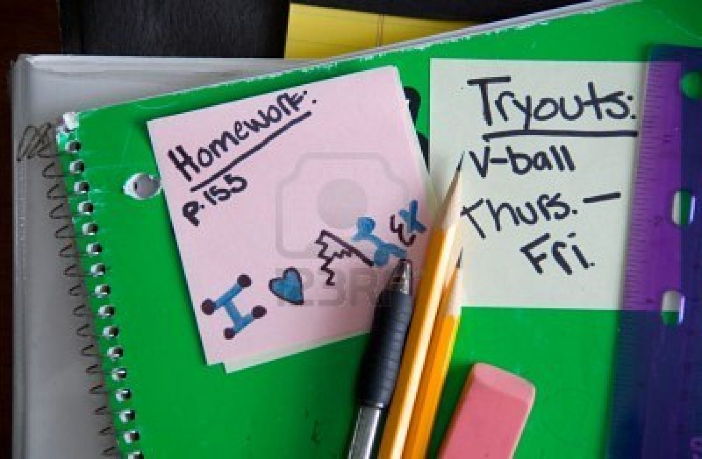 | 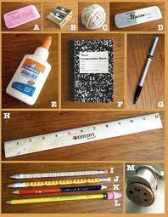
- Marie’s desk is on the left and Jeanne’s is on the right. Tell at least six school supplies that each student has brought. Use un, une, and des before each of them…
Marie a…  __________________________________  __________________________________  __________________________________  __________________________________  __________________________________  __________________________________ | Jeanne a…  __________________________________  __________________________________  __________________________________  __________________________________  __________________________________  __________________________________
- You want to borrow certain supplies from Marie (left desk) . Marie wants to be helpful. Look at the picture showing her supplies to decide how she would answer your questions.
Exemple: Tu as un cahier, Marie? Oui j’ai un cahier.
Tu as un feutre ? Non, je regrette. Je n’ai pas de feutre.

- Tu as un crayon ? __________________________________________________________________________

- Tu as un sac ? _____________________________________________________________________________

- Tu as un stylo ? ____________________________________________________________________________

- Tu as une feuille de papier ? __________________________________________________________________

- Tu as une calculatrice ? ______________________________________________________________________

