French 2A: Unit 2 Au Passé
Culminating Assessment
Nom _____________________
Heure ____________________
La Mauvaise Journée de…
You are going to be create a fictional story about someone’s bad day. Your character may be either real or made up, human or animal, be as creative as you wish as long as you can use the unit vocabulary/grammar. However you must…
- Have a cover page with a French title and illustration
- Say how the character’s day was
- Use all 4 transition words “D’abord” “Puis/Ensuite” “Après (ça)” “Enfin/Finalement”
- Have 5 pages with two or more sentences each
- Have at least 5 pages of illustration to show what happened (as if I couldn’t read the French)
- Use the “school day verbs” to say what happened in the passé composé (at least 5)
- 2 sentences must be negative (ne…pas) of something that didn’t happen
Other Culminating Assessment Options:
- Film your story while saying the lines for a speaking instead of writing grade
- Make a cartoon using the above criteria
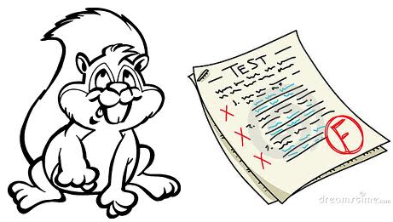
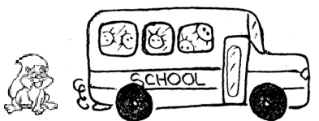
D’abord Spike a raté le bus. Il a raté un examen aussi.

 | 10 | 8 | 6 | 4 | 0
Correctly use a range of vocabulary | The student makes excellent use of a basic range of vocabulary. Vocabulary is accurate. | The student makes good use of a basic range of vocabulary. Vocabulary is generally accurate. | The student uses a basic range of vocabulary. There are some errors that interfere with communication. | The student uses a limited range of vocabulary. There are frequent errors that interfere with communication. | The student does not reach a standard described by any of the descriptors given below.
Correctly use a range of grammatical structures  (x2 points) | The student makes excellent use of a basic range of grammatical structures and uses some more-complex structures. Grammar is accurate. | The student makes good use of a basic range of grammatical structures. Grammar is generally accurate and there are some attempts at more-complex structures. | The student uses a basic range of grammatical structures and there are some errors that interfere with communication. | The student uses a limited range of grammatical structures and there are frequent errors that interfere with communication. | The student does not reach a standard described by any of the descriptors given below.
Show accuracy in spelling or writing of characters (or speaking if filming) | There may be occasional errors in spelling/writing, but these do not interfere with communication. | There are some errors in spelling/writing, but these do not interfere with communication. | There are some errors in spelling/writing that sometimes interfere with communication. | Spelling/writing often impede communication. | The student does not reach a standard described by any of the descriptors given below.
Completion of Requirements | Completed all presentation requirements. | Completed the majority of the presentation requirements. | Completed some of the presentation requirements. | Completed minimal presentation requirements. | Did not attempt to meet the criteria.
TOTAL POINTS: _____ /40

French Book Title: _______________________________________________________________________________
Illustration(s)
Chapter 9 verbs I plan on using:
5 things that happened 2 things that didn’t happen

Now plan out your story & illustrations with 2 sentences per page.
How character’s day was (Name had a…day). : _________________________________________________________
Page 1 D’abord __________________________________________________________________________________
__________________________________________________________________________________
Illustration(s)

Page 2 Ensuite __________________________________________________________________________________
__________________________________________________________________________________
Illustration(s)

Page 3 Puis _________________________________________________________________________________
__________________________________________________________________________________
Illustration(s)

Page 4 Après ça _________________________________________________________________________________
__________________________________________________________________________________
Illustration(s)

Page 5 Finalement ________________________________________________________________________________
__________________________________________________________________________________
Illustration(s)

LA FIN!

