Which 16 (17) verbs use être as the helping verb in the past tense?? Here’s an acronym to help you memorize them:
On the first line fill in the infinitive of the verb. On the second line write the past participles (é / i/ u, except for the *).
D_____________________ *______________________
(to become)
R_____________________ * ______________________
(to come back)
M_____________________ _____________________
(to climb/go up)
R_____________________ ______________________
(to stay)
S_____________________ ______________________
(to go out)

(P.) Passer passé
(sometimes uses être if you’re saying you passed by)
*not for to take a test/quiz etc

V_____________________ * _____________________
(to come)
A_____________________ ______________________
(to arrive)
N_____________________ *_____________________
(to be born)
D_____________________ ______________________
(to go down, get off, descend)
E_____________________ ______________________
(to enter)
R_____________________ ______________________
(to return)
T_____________________ ______________________
(to fall)
R_____________________ ______________________
(to come back home)
A_____________________ ______________________
(to go)
M_____________________ *____________________
(to die)
P_____________________ ______________________
(to leave)

Song Tune: 10 Little Indians
French 2B: Unit 2- Had a Bad Day Again
Page des Notes – Dr. Mrs. Vandertramp
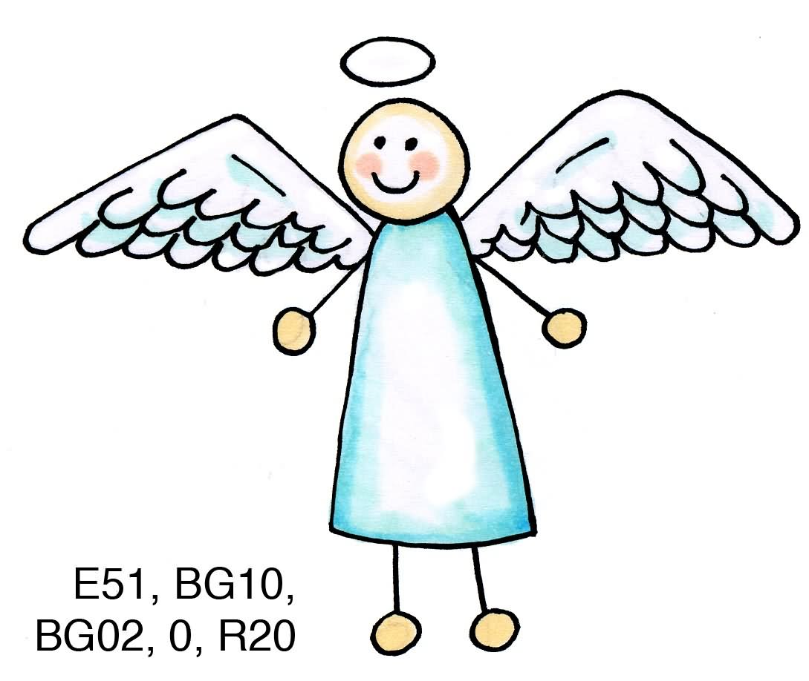
_______________

__________________

_______________
_______________
_______________
_______________

________________
_______________
_______________
_______________
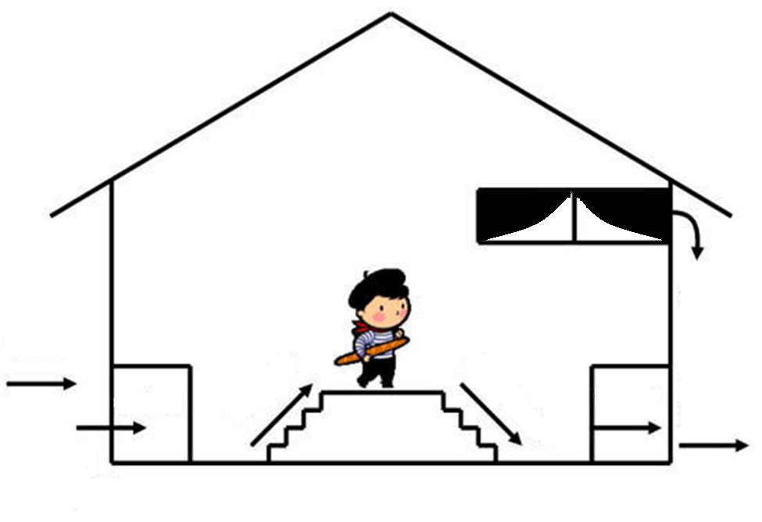

Nom ________________________
Heure _______________________

_______________
_______________

