Go to: http://www.fotobabble.com/ (It works best in Google Chrome)
Create an account (I would use the same username & password that you use for school so you can easily remember it).
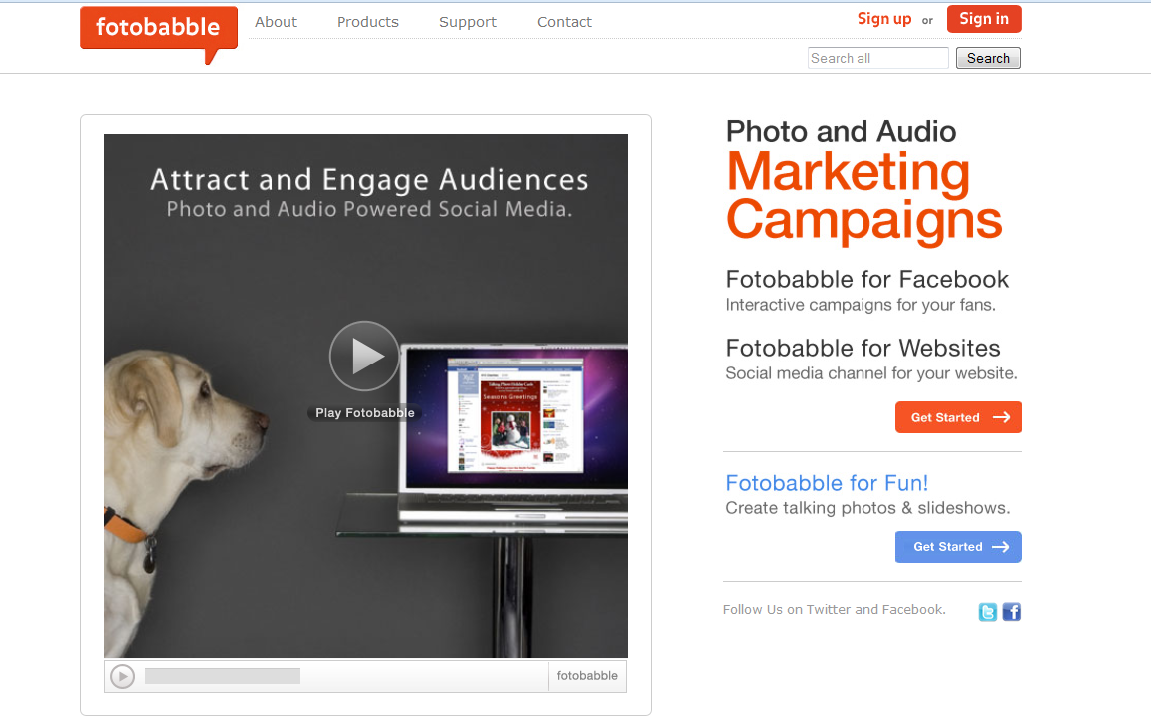
Once you sign in click on “Create A Fotobabble” or “Create New” if it doesn’t open automatically.
You will then need to upload a photo of yourself. Make sure it is school appropriate and that it is preferable just of you. You have to upload an image before it will let you move on so if you’re just testing it out at first upload any appropriate image and you can edit it later after you choose a photo.
If you don’t want to upload an image from your computer and want an image from Facebook instead then you will need to login to facebook to upload it.
Click browse and then choose the photo that is saved on your computer. Then click create.
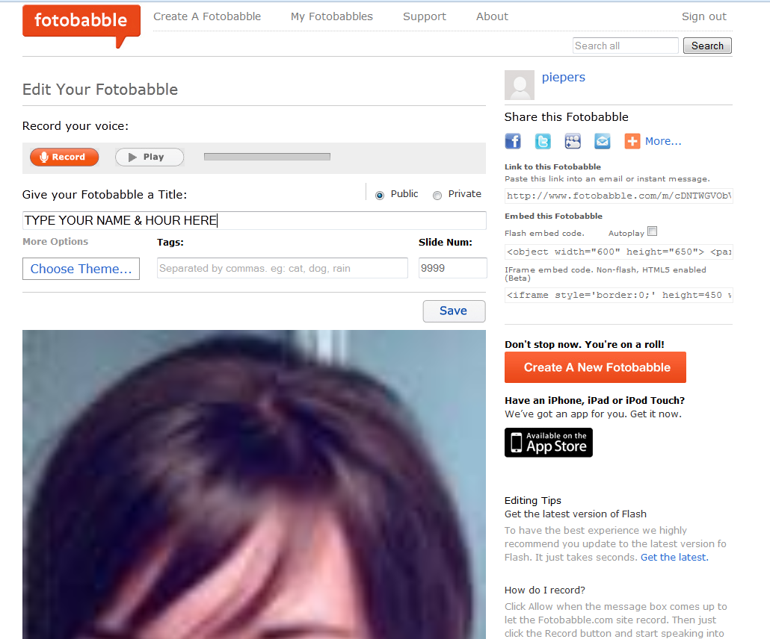
Make sure you have a laptop that records your voice (you may need to speak really close to it) or if you have a PC computer you will need to plug in a microphone.
Then click “record” to record your French speaking.
Be sure to hit “allow when the box pops up.
When finished click “stop” and you can click ”play” to listen to it. If you want to re-record just hit “record” and repeat the process as many times as you need.

Then give your Fotobabble a name (Use your name and hour).
If you want a border around your photo you can click “Choose a theme”
When finished click “save” .

MERCI!!! Good work!
You then need to send me the link to your Fotobabble. You can either click the blue letter that’s for email and send it to piepers@westottawa.net (make the subject your name & hour).
Or you can copy and paste the URL in an email to me (piepers@westottawa.net).

